CSA5159 Cryptography and Network Security for Infrastructure Protection
Programs 4 - 10

4. Write a C program for polyalphabetic substitution cipher uses a separate monoalphabetic substitution
cipher for each successive letter of plaintext, depending on a key.
Program:
def encrypt(text, key):
result = ""
key = key.upper()
j = 0

for ch in text.upper():
if ch.isalpha():
shift = ord(key[j % len(key)]) - ord('A')
result += chr((ord(ch) - ord('A') + shift) % 26 + ord('A'))
j += 1
else:
result += ch
return result

def decrypt(cipher, key):
result = ""
key = key.upper()
j = 0

for ch in cipher.upper():
if ch.isalpha():
shift = ord(key[j % len(key)]) - ord('A')
result += chr((ord(ch) - ord('A') - shift) % 26 + ord('A'))
j += 1
else:
result += ch
return result

text = input("Enter plaintext: ")
key = input("Enter key: ")

cipher = encrypt(text, key)
print("Encrypted:", cipher)
print("Decrypted:", decrypt(cipher, key))
Output:
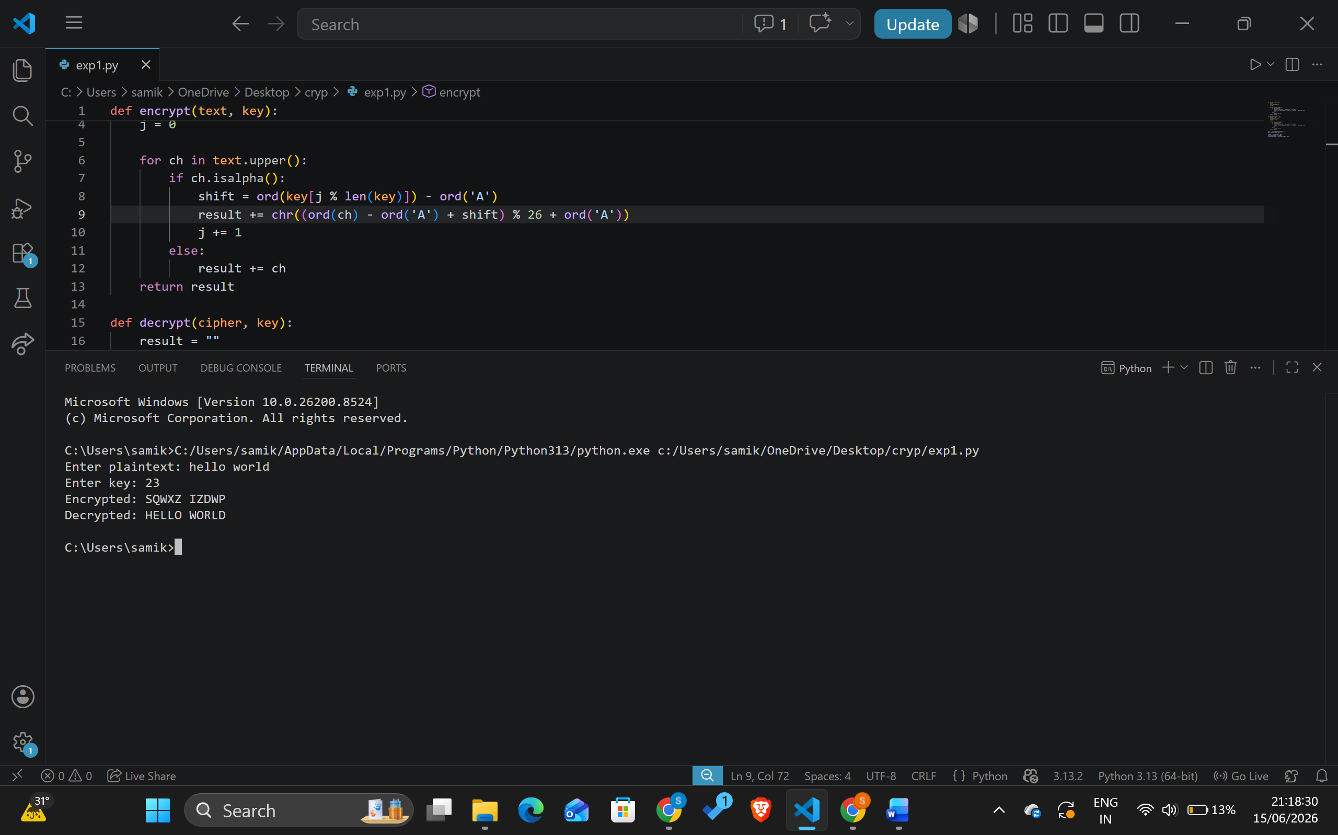

5. Write a C program for generalization of the Caesar cipher, known as the affine Caesar cipher, has the
following form: For each plaintext letter p, substitute the ciphertext letter C: C = E([a, b], p) = (ap + b)
mod 26 A basic requirement of any encryption algorithm is that it be one-to-one. That is, if p q, then
E(k, p) E(k, q). Otherwise, decryption is impossible, because more than one plaintext character maps into
the same ciphertext character. The affine Caesar cipher is not one-to-one for all values of a. For example,
for a = 2 and b = 3, then E([a, b], 0) = E([a, b], 13) = 3.
a. Are there any limitations on the value of b?
b. Determine which values of a are not allowed.
Program:
def mod_inverse(a, m):
for x in range(1, m):
if (a * x) % m == 1:
return x
return None

def encrypt(text, a, b):
result = ""
for ch in text.upper():
if ch.isalpha():
x = ord(ch) - 65
result += chr(((a * x + b) % 26) + 65)
return result

def decrypt(cipher, a, b):
result = ""
a_inv = mod_inverse(a, 26)

for ch in cipher:
x = ord(ch) - 65
result += chr((a_inv * (x - b)) % 26 + 65)

return result

text = input("Enter plaintext: ")
a = int(input("Enter a: "))
b = int(input("Enter b: "))

cipher = encrypt(text, a, b)
print("Cipher:", cipher)
print("Plain:", decrypt(cipher, a, b))
Output:
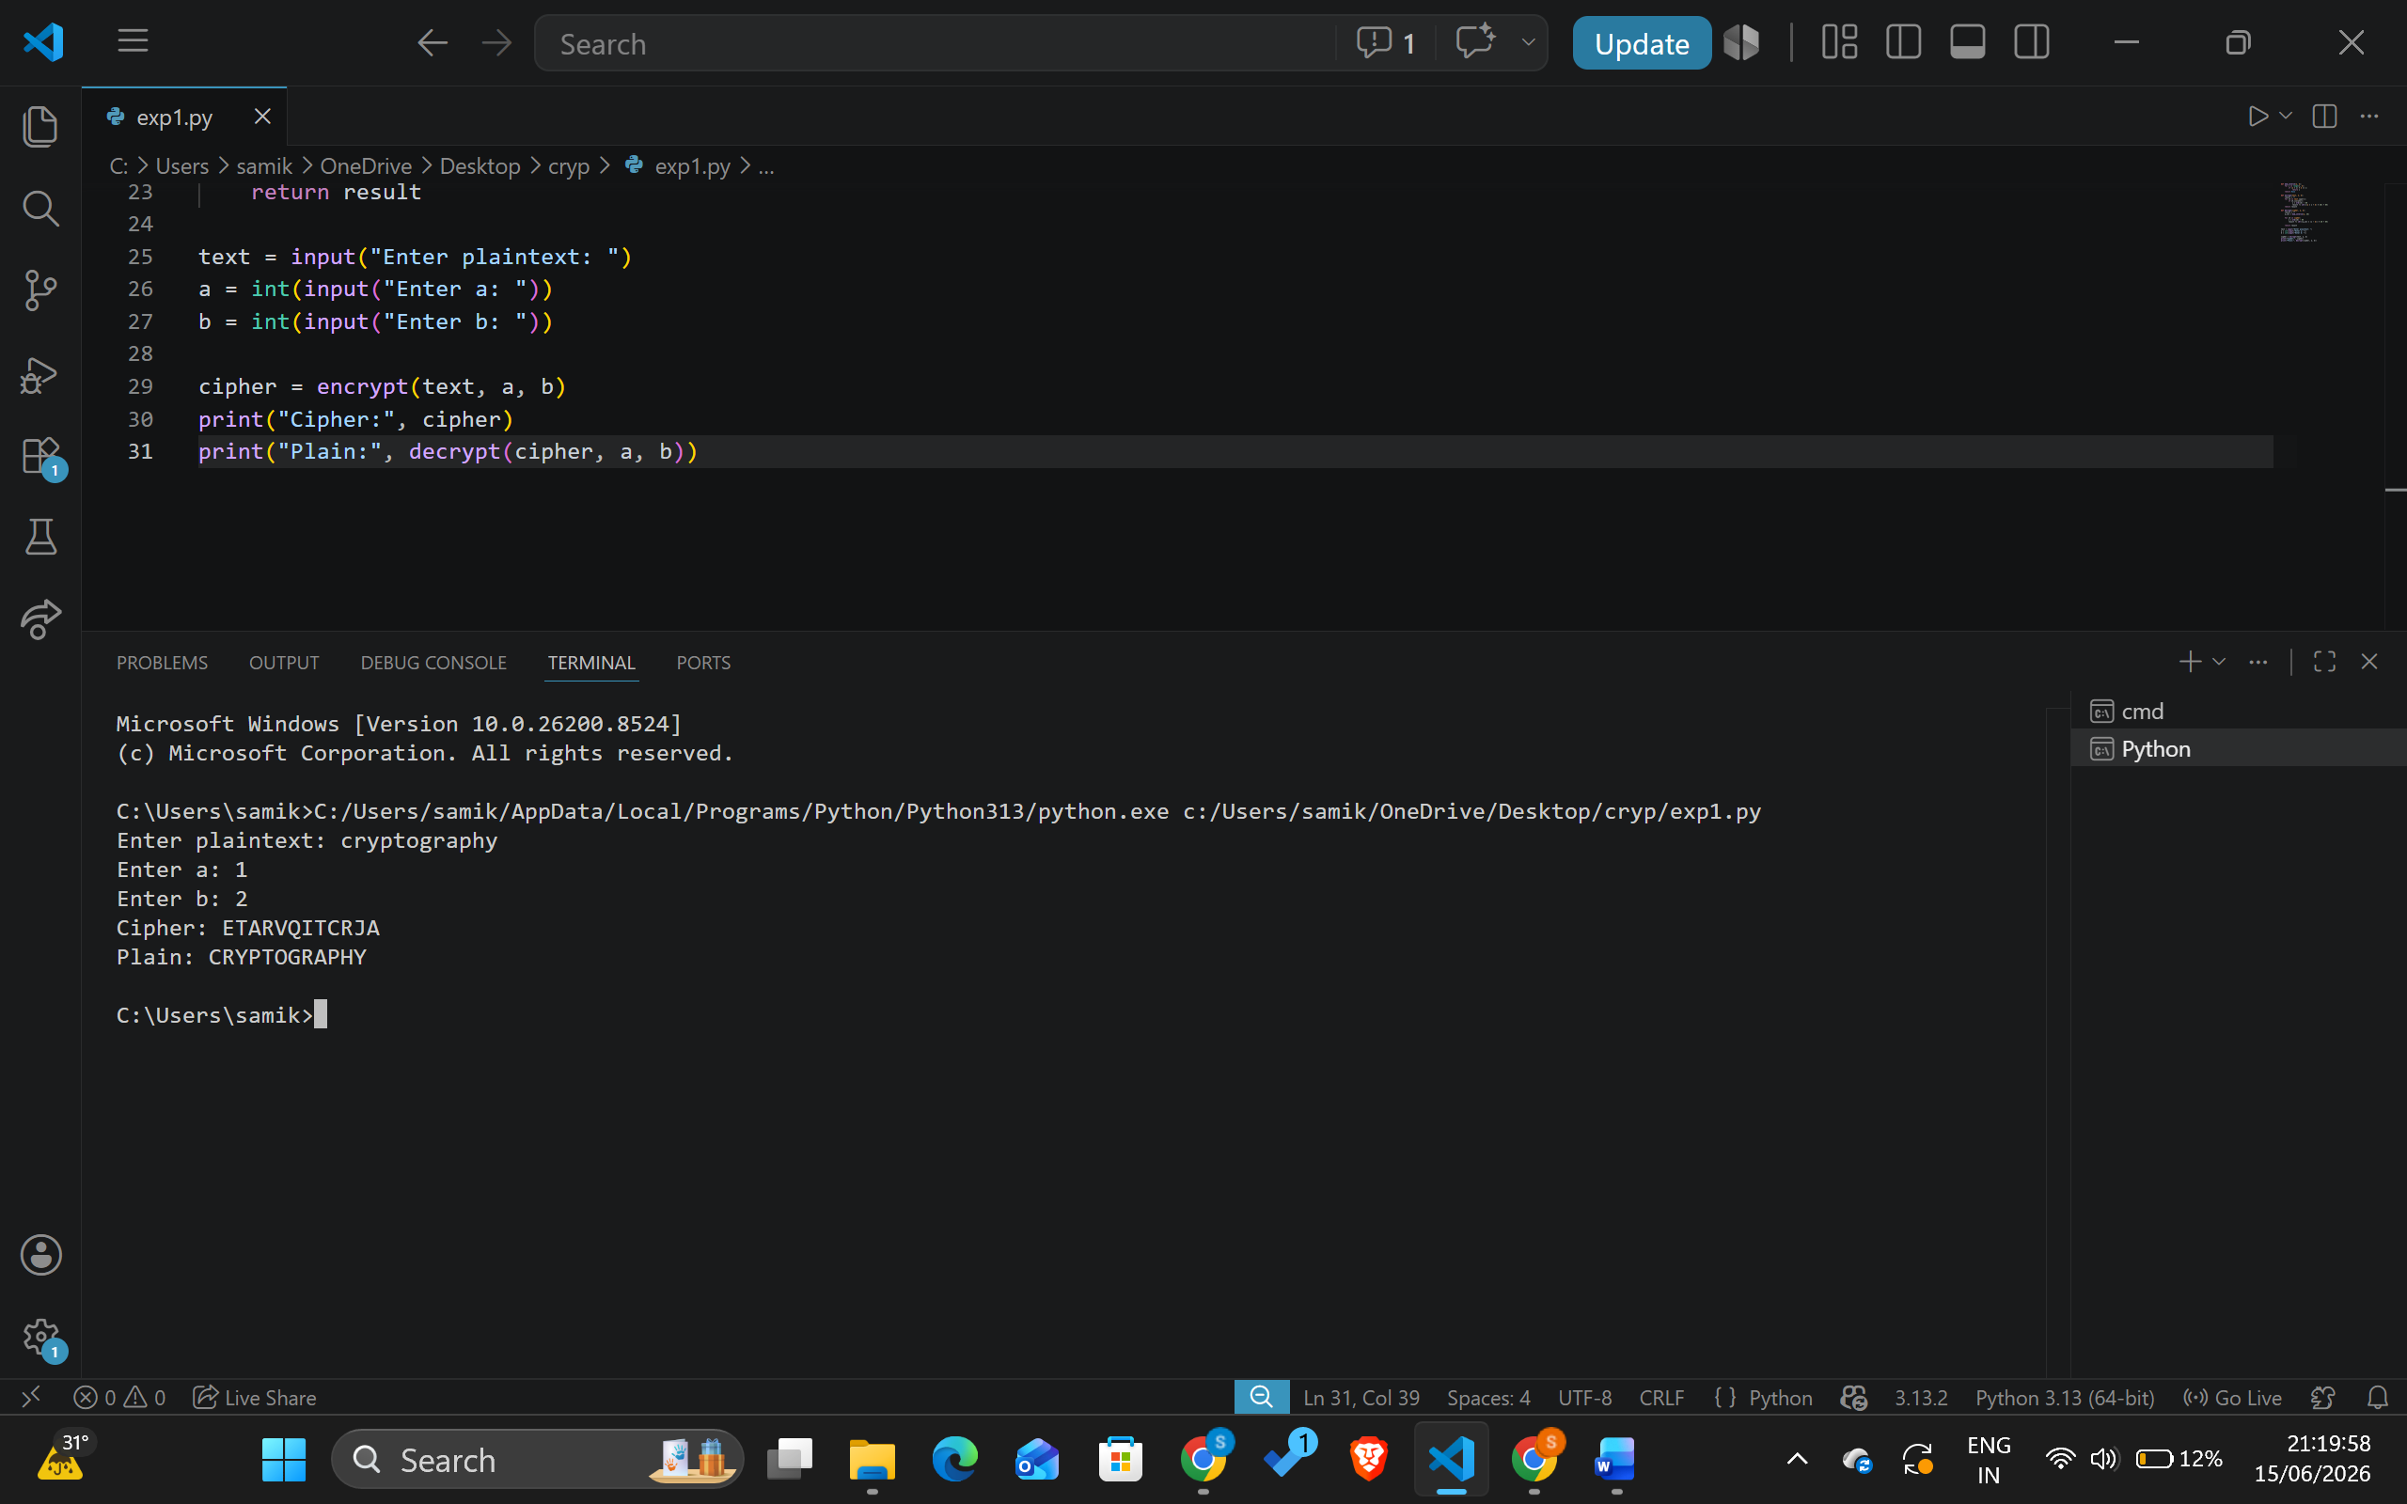

6. Write a C program for ciphertext has been generated with an affine cipher. The most frequent letter of the ciphertext is “B,” and the second most frequent letter of the ciphertext is “U.” Break this code.
Program:
from math import gcd

cipher = input("Enter ciphertext: ").upper()

for a in range(1, 26):
if gcd(a, 26) == 1:
for b in range(26):

a_inv = None
for x in range(26):
if (a * x) % 26 == 1:
a_inv = x
break

plain = ""

for ch in cipher:
if ch.isalpha():
p = (a_inv * ((ord(ch)-65) - b)) % 26
plain += chr(p + 65)

print(f"a={a}, b={b} => {plain}")
Output:
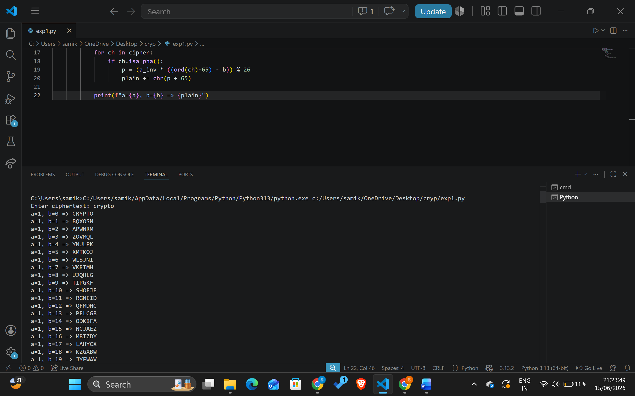
7. Write a C program for the following ciphertext was generated using a simple substitution algorithm.
53‡‡†305))6*;4826)4‡.)4‡);806*;48†8¶60))85;;]8*;:‡*8†83
(88)5*†;46(;88*96*?;8)*‡(;485);5*†2:*‡(;4956*2(5*—4)8¶8*
;4069285);)6†8)4‡‡;1(‡9;48081;8:8‡1;48†85;4)485†528806*81 (‡9;48;(88;4(‡?34;48)4‡;161;:188;‡?;
Decrypt this message.
1. As you know, the most frequently occurring letter in English is e. Therefore, the first or second (or
perhaps third?) most common character in the message is likely to stand for e. Also, e is often seen in
pairs (e.g., meet, fleet, speed, seen, been,
agree, etc.). Try to find a character in the ciphertext that decodes to e.
2. The most common word in English is “the.” Use this fact to guess the characters that stand for t and h.
3. Decipher the rest of the message by deducing additional words.
Program:
from collections import Counter

cipher = input("Enter ciphertext: ")

freq = Counter(cipher)

print("Character Frequency:")
for k, v in freq.most_common():
print(k, ":", v)
Output:

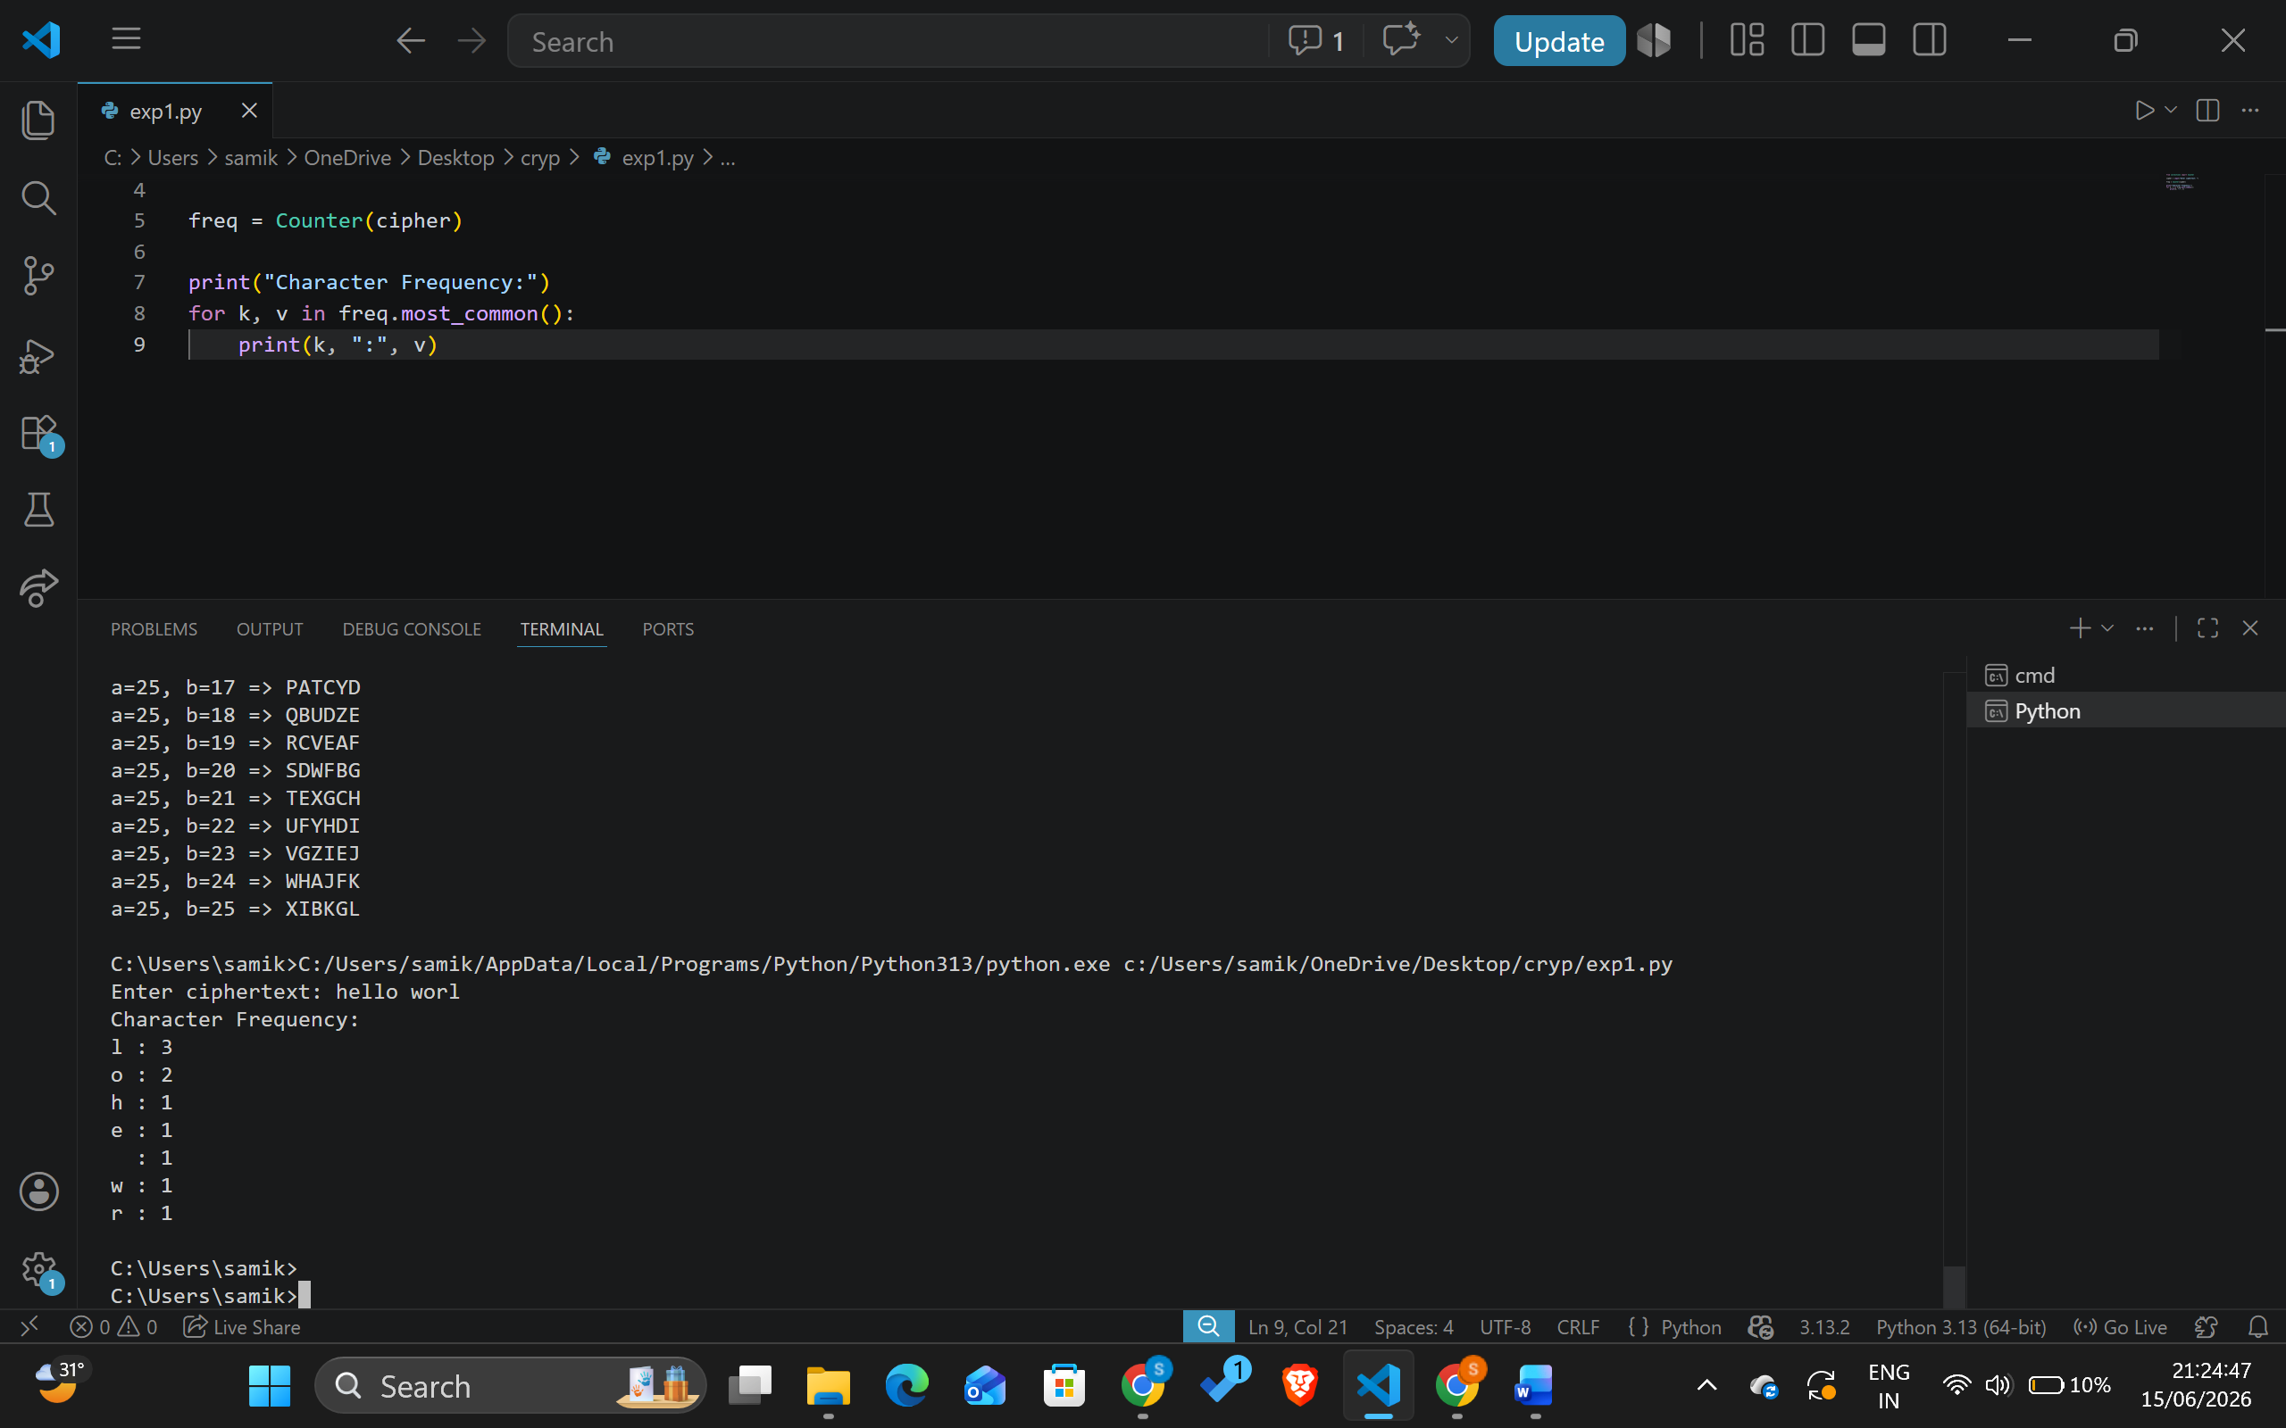

8. Write a C program for monoalphabetic cipher is that both sender and receiver must commit the
permuted cipher sequence to memory. A common technique for avoiding this is to use a keyword from
which the cipher sequence can be generated.
For example, using the keyword CIPHER, write out the keyword followed by unused letters in normal
order and match this against the plaintext letters:

plain: a b c d e f g h i j k l m n o p q r s t u v w x y z
cipher: C I P H E R A B D F G J K L M N O Q S T U V W X Y Z
Program:
import string

keyword = input("Keyword: ").upper()

alphabet = string.ascii_uppercase

cipher_alpha = ""

for ch in keyword:
if ch not in cipher_alpha:
cipher_alpha += ch

for ch in alphabet:
if ch not in cipher_alpha:
cipher_alpha += ch

mapping = dict(zip(alphabet, cipher_alpha))
reverse = dict(zip(cipher_alpha, alphabet))
text = input("Text: ").upper()
cipher = ''.join(mapping.get(c, c) for c in text)
plain = ''.join(reverse.get(c, c) for c in cipher)
print("Cipher:", cipher)
print("Plain:", plain)
Output: 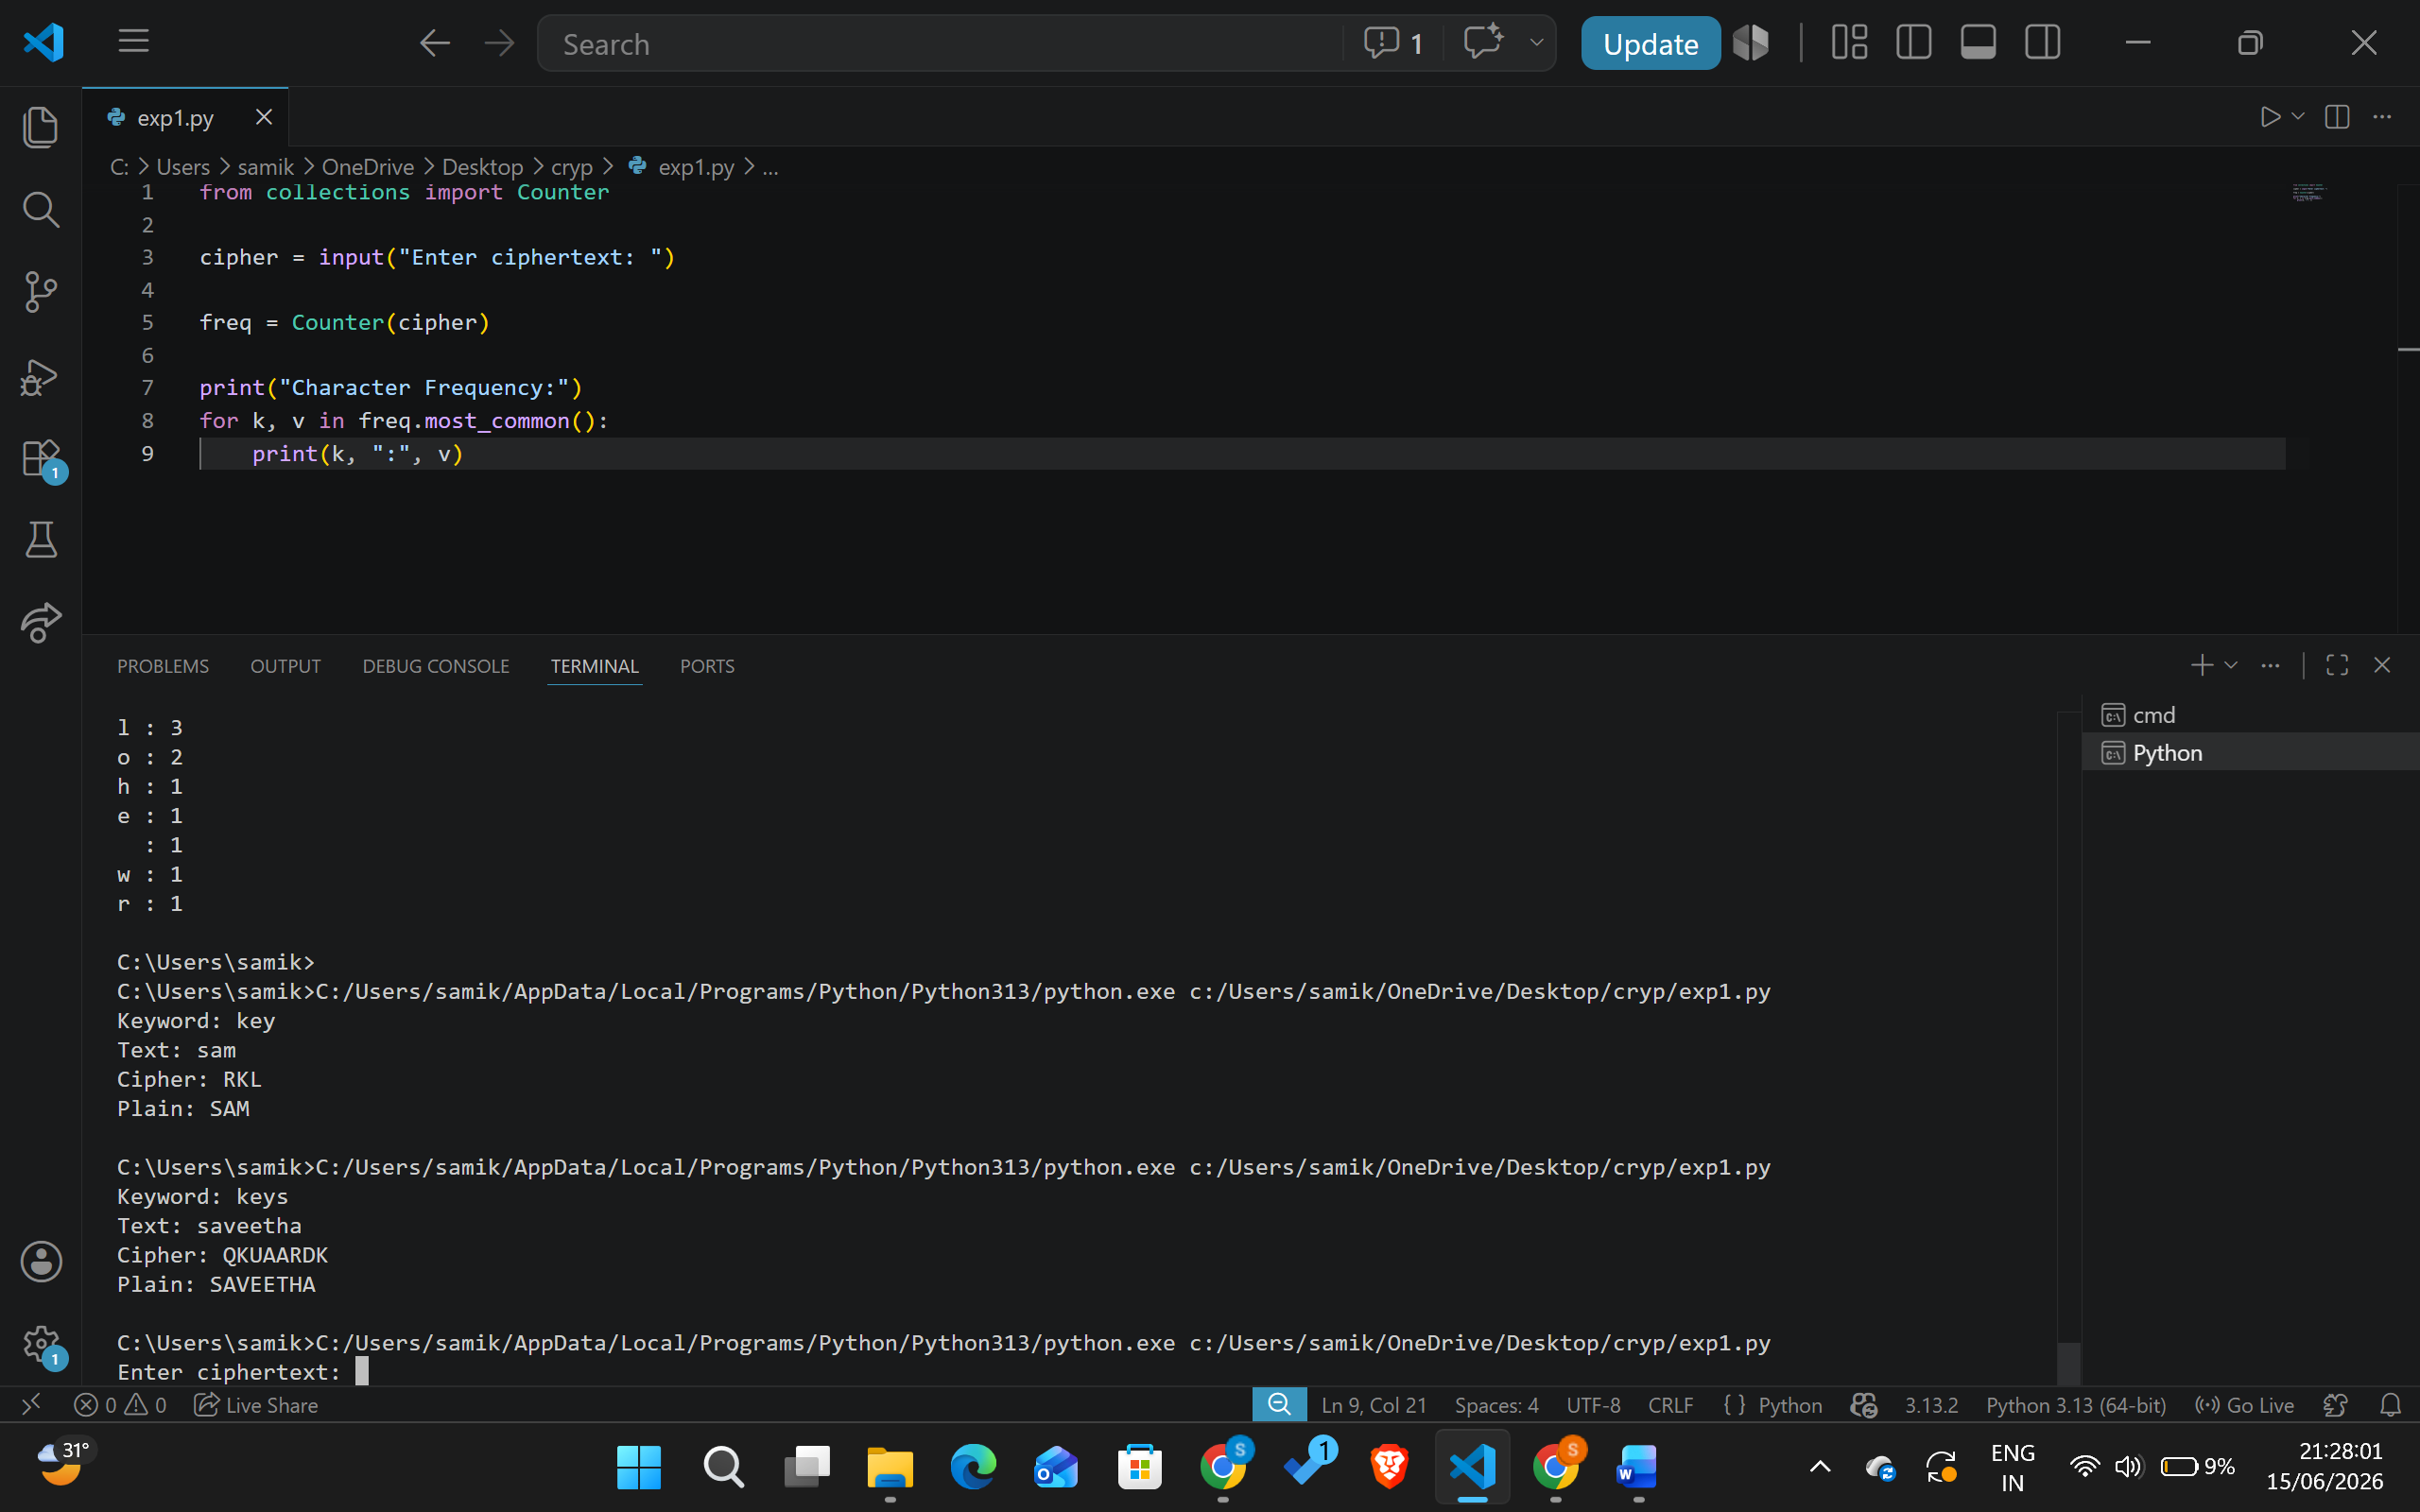

9. Write a C program for PT-109 American patrol boat, under the command of Lieutenant John F.
Kennedy, was sunk by a Japanese destroyer, a message was received at an Australian wireless station in
Playfair code:
KXJEY UREBE ZWEHE WRYTU HEYFS
KREHE GOYFI WTTTU OLKSY CAJPO
BOTEI ZONTX BYBNT GONEY CUZWR
GDSON SXBOU YWRHE BAAHY USEDQ

Program:
def generate_matrix(key):
key = key.upper().replace("J", "I")
matrix = []

for ch in key:
if ch not in matrix:
matrix.append(ch)

for ch in "ABCDEFGHIKLMNOPQRSTUVWXYZ":
if ch not in matrix:
matrix.append(ch)

return [matrix[i:i+5] for i in range(0, 25, 5)]

def display(mat):
for row in mat:
print(row)

key = input("Key: ")
display(generate_matrix(key))
Output:
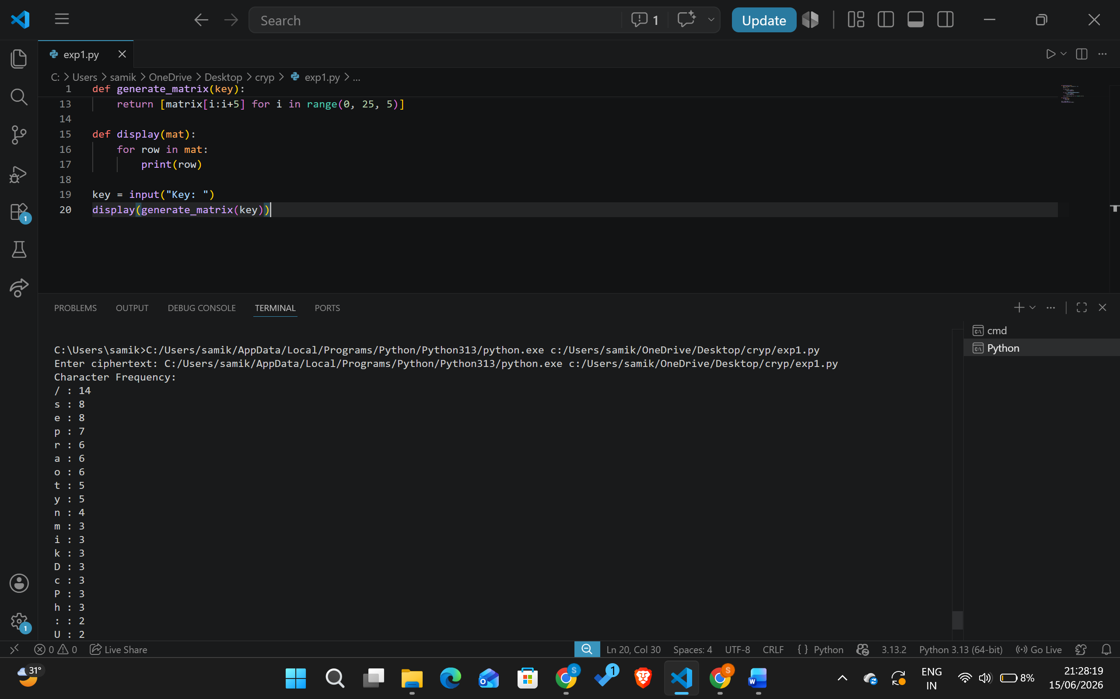

10. Write a C program for Playfair matrix:
M F H I/J K
U N O P Q
Z V W X Y
E L A R G
D S T B C
Encrypt this message: Must see you over Cadogan West. Coming at once.
Program:
def create_matrix(key):
key = key.upper().replace('J','I')

matrix = []

for c in key:
if c not in matrix:
matrix.append(c)

for c in "ABCDEFGHIKLMNOPQRSTUVWXYZ":
if c not in matrix:
matrix.append(c)

return [matrix[i:i+5] for i in range(0,25,5)]

def locate(matrix, ch):
for r in range(5):
for c in range(5):
if matrix[r][c] == ch:
return r,c

def encrypt_pair(a,b,matrix):
r1,c1 = locate(matrix,a)
r2,c2 = locate(matrix,b)

if r1 == r2:
return matrix[r1][(c1+1)%5] + matrix[r2][(c2+1)%5]

elif c1 == c2:
return matrix[(r1+1)%5][c1] + matrix[(r2+1)%5][c2]

else:
return matrix[r1][c2] + matrix[r2][c1]

key = input("Key: ")
matrix = create_matrix(key)

text = input("Plaintext: ").upper().replace(" ","").replace("J","I")

pairs = []
i = 0

while i < len(text):
a = text[i]
b = text[i+1] if i+1 < len(text) else 'X'

if a == b:
pairs.append(a+'X')
i += 1
else:
pairs.append(a+b)
i += 2

cipher = ""

for p in pairs:
cipher += encrypt_pair(p[0], p[1], matrix)

print("Cipher:", cipher)

Output:
